KHULNA UNIVERSITY OF ENGINEERING & TECHNOLOGY
KHULNA 9203

Application for the Approval of Thesis/Project Proposal for the Degree of
M.Sc. Eng./MURP/M.Sc./M. Phil/Ph.D.
(Approved in 55th CASR)

[All instructions given in the square bracket must be deleted while writing the proposal]
[Throughout the proposal use Page Layout: Size: A4, Margin: 1 inch (all sides), Font name: Times New Roman, Font size: 12, Line spacing: single]

1. Name of the student (In English) : FARJANA BITHI [CAPITAL LETTERS]
(In Bengali) : dviRvbv we_x [Unicode Font: SolaimanLipi, Nikosh]
Roll No. : 1901551 Status (Full Time/Part Time) : Full Time

2. Present Address : Room No-2100, Rokeya Hall, KUET
(Mailing/Contact Address in Details) Email: farja1901551@stud.kuet.ac.bd
Mobile: 01211000000

3. Name of the Department/Institute : Civil Engineering

4. Name of the Program : M.Sc. Eng.
(M.Sc. Eng./MURP/M.Sc./
M.Phil./Ph.D.)

5. Credit-hours of Thesis/Project : 18 credits
(9/18/24/45 credits)

6. Date of First Enrollment in the : 10/01/2020
Program

7. Semester of First Enrollment : January, 2020

8. Name, Designation & Department : Dr. Nazmul Alam, Professor, Dept. of CE
of the Thesis/Project Supervisor

9. Proposed Title of the Thesis/Project: Template of Research Proposal for the Post Graduate Research at KUET
[Title case, bold, no dot or full stop at the end of title; Reflect the theme/focus of the research; Be precise, unique, concise and self-explanatory, try to avoid abbreviated form; Language will be simple, unambiguous and not vague; Limit: 8-15 words (preferred)]

10. Background and Motivation of the Proposed Research:
(Brief background and scope of the research work in 500 to 1000 words for M.Sc. Eng./MURP/M.Sc./M.Phil. and 1000-2000 words for Ph.D.)

[This is brief section explaining the contemporary developments in the field. The section should explain: Why is the study needed? What is the theoretical and/or practical significance? What are the most important works done in this area? (Provide references) What are limitations of their study? More specifically what are the goals of the study?

At the end, outline the specific contribution of the present research including the gap, goal, scope, broader impact, and application]

11. Research Objectives:
(This section should be within 150 words) [Objective(s) has to be linked with all components of the research proposal; State overall objective in 1-3 sentence(s); Write 3-7 specific objectives (small roman number); Be specific and concise; Use appropriate higher order action verbs for specific objectives. The specific objectives of the research are to-
- apply/construct/compare/contrast/…,
- measure/evaluate/analyze/ propose/collect…, and
- formulate/model/design/create/combine/…]

12. Research Methods:
(Write as much detail as possible within 500 to 1000 words for M.Sc. Eng./MURP/M.Sc./M.Phil. and 1000-1500 words for Ph.D.) [Describe the technical research methods in the well organized form (future tense, passive voice, and third person preferred); If applicable, you can mention: Sampling and testing protocol; Qualitative and quantitative method; Model/software boundary conditions, limitations, and validation; Equipment calibration and precision; Data collection, extraction, and generation; Data analysis and presentation; May provide flowchart of methods; If applicable, consider ethical issues; Consider safety and environmental hazard issues; Consider risk assessment.

Use figures and tables with appropriate captions as necessary. Fig. 1 is an example of a figure and Table 1 shows an example of a table.

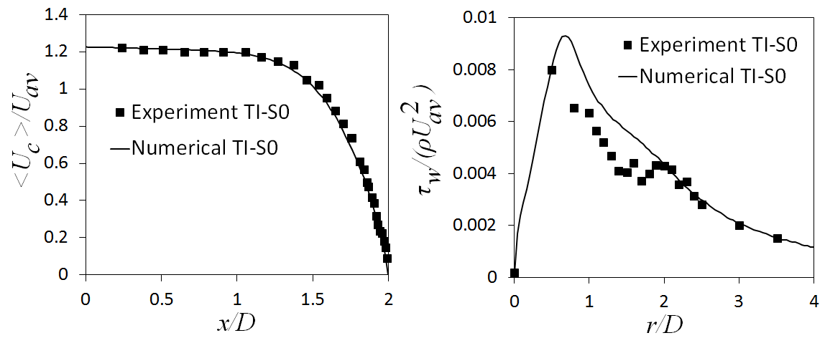

Fig. 1: Example of a figure

Table 1: Example of a Table

Author | Year | T | p | Ref.
Keyes | 1918 | 240-398 | 0.103-9.96 | 1
--
--

Use a Gantt chart for maintaining your timeline for the proposed research (This is optional for M.Sc. Eng./MURP/M.Sc./M.Phil. but mandatory for Ph.D.)] Table 2 shows a sample Gantt chart.
Table 2: Timeline for Completing the Thesis

 | Year 1 |  |  |  |  |  |  |  |  |  |  |  | Year 2 |  |  |  |  |  |  |  |  |  |  |  | Year 3
 | Q1 |  |  | Q2 |  |  | Q3 |  |  | Q4 |  |  | Q1 |  |  | Q2 |  |  | Q3 |  |  | Q4 |  |  | Q1 |  |  | Q2 |  |  | Q3 |  |  | Q4
Literature Review
Research Proposal
Research Activities...
Data collection
Activity 1…..
Activity 2…..
Thesis writing
Submission of Thesis

13. Expected Results:
(Write expected results of the research work within 150 to 300 words for M.Sc. Eng./MURP/M.Sc./M.Phil./Ph.D.) [The mapping between specific objectives and expected results (output and outcome) is necessary; predict the significance of the study and expected outcomes of the research; mention the research impact and influence in broader perspective. Write 3-5 specific expected results (small roman number). The expected results of the research are-
- expected results 1
- expected results 2, and
- expected results 3]

14. References:
[Use only relevant articles to your research focus. Use peer-reviewed journal articles, books, reputed conference proceedings; Use recent articles; Use either APA or IEEE referencing and citation style. References should be within 8-15 nos. for M.Sc. Eng./MURP/M.Sc./M.Phil. and 15-25 nos. for Ph.D. All references must be cited in the text.

Sample References (IEEE Style)
//Journal articles:
[1] Gil-Costa, Veronica, Mauricio Marin, and Nora Reyes. "Parallel query processing on distributed clustering indexes." Journal of Discrete Algorithms 7, no. 1 (2009): 3-1
// Conference proceedings:
[2] Chou, Jerry, and Kesheng Wu. "Fastquery: A parallel indexing system for scientific data." In 2011 IEEE International Conference on Cluster Computing, pp. 455-464. IEEE, 2011.
//Book
[3] Han, Jiawei, Jian Pei, and Micheline Kamber. Data mining: concepts and techniques. Elsevier, 2011.

Details of IEEE referencing and citation style can be found at:
https://ieeeauthorcenter.ieee.org/wp-content/uploads/IEEE-Reference-Guide.pdf

Sample References (APA Style)
//Journal paper
Askitis, N., Sinha, R., 2010. Engineering scalable, cache and space efficient tries for strings. The VLDB Journal 19, 633-660.
// Conference proceedings
Le, C.A., Shimazu, A., 2004. High WSD accuracy using naive Bayesian classifier with rich features, in: Proceedings of the 18th Pacific Asia Conference on Language, Information and Computation, pp. 105- 114.
//Book
Stoneman, R. (2008). Alexander the Great: A life in legend. Yale University Press.

Details of APA referencing and citation style can be found at: https://libguides.murdoch.edu.au/APA]

15 (I). Estimated Budget
Sl. No | Item | Quantity & Unit | Unit Price | Total Price
A | Materials  i.  ii.
B | Equipment  i.  ii.
C | Labor and others
D | Research Publication (Referred Journal/International Conference)  (Maximum amount: Tk. 15,000 for M.Sc. Eng./MURP/M.Sc./M.Phil.)  (Maximum amount: Tk. 25,000 for Ph.D.)
E | Thesis/Project Typing, Printing and Binding  M.Sc. Eng./MURP/M.Sc. (Maximum amount: Tk. 3,000)  M.Phil. (Maximum amount: Tk. 3,500)  Ph.D. (Maximum amount: Tk. 5,000)
F | Miscellaneous: (Maximum amount: Tk. 5,000)
Total (In Figure):
In words:

15 (II). Budget Justification
(Write justification of budget within 150 to 300 words) [Ensure that the topic can be addressed within a realistic budget; Require budget justification for major items; Provide the link between budget and research method]

Signature of the Student

16. List of Courses Taken:

Sl. No. | Course No. | Title of the Course | Credit Hours | Letter  Grade | Grade Point | Grade Point Average
1.
2.
3.

17. Total Credit-hours Completed (Theory):

Signature of the Course Coordinator

For Official Use Only

18. Is the Proposal related with the UGC funded research project? Yes/No
(If yes, fill up the following)
Title of the Project:
Financial year:

19. No. of post graduate students presently working with the Supervisor:

20. Name and Designation of the Joint Supervisor/Co-Supervisor (if any):

21. Justification of having Joint Supervisor/Co-Supervisor (if any):

22. Date and Resolution No. of the Meeting of ACPG/DSC/ARC:
Meeting No. ........................ Date .......................... Resolution No. ............

Signature of the  Joint Supervisor/Co-Supervisor (If any) |  | Signature of the Supervisor |  | Signature of the Head of the Department/Director of the Institute

